Module 3 - PL/SQL Programming
Exercise 3: Stored Procedures
Creating Tables:

Accounts Table:

CREATE TABLE Accounts (
AccountID NUMBER PRIMARY KEY,
CustomerName VARCHAR2(50),
AccountType VARCHAR2(20),
Balance NUMBER(10,2)
);

Employees Table:

CREATE TABLE Employees (
EmployeeID NUMBER PRIMARY KEY,
EmployeeName VARCHAR2(50),
Department VARCHAR2(30),
Salary NUMBER(10,2)
);

Inseting data:

Accounts Table:

INSERT INTO Accounts VALUES (101, 'Ravi', 'Savings', 10000);
INSERT INTO Accounts VALUES (102, 'Priya', 'Savings', 15000);
INSERT INTO Accounts VALUES (103, 'Amit', 'Current', 20000);
INSERT INTO Accounts VALUES (104, 'Neha', 'Savings', 12000);

COMMIT;

Employees Table:

INSERT INTO Employees VALUES (1, 'John', 'IT', 50000);
INSERT INTO Employees VALUES (2, 'Alice', 'IT', 60000);
INSERT INTO Employees VALUES (3, 'Bob', 'HR', 45000);
INSERT INTO Employees VALUES (4, 'Emma', 'HR', 55000);

COMMIT;

Scenario 1: The bank needs to process monthly interest for all savings accounts.
  - Question: Write a stored procedure ProcessMonthlyInterest that calculates and updates the balance of all savings accounts by applying an interest rate of 1% to the current balance.

Program Code:
CREATE OR REPLACE PROCEDURE ProcessMonthlyInterest
IS
BEGIN
UPDATE Accounts
SET Balance = Balance + (Balance * 0.01)
WHERE AccountType = 'Savings';

COMMIT;

DBMS_OUTPUT.PUT_LINE('=================================');
DBMS_OUTPUT.PUT_LINE(' MONTHLY INTEREST PROCESSING ');
DBMS_OUTPUT.PUT_LINE('=================================');
DBMS_OUTPUT.PUT_LINE('1% interest applied to all Savings Accounts.');
DBMS_OUTPUT.PUT_LINE('Balances updated successfully.');
DBMS_OUTPUT.PUT_LINE('Transaction Completed.');
END;
/

SET SERVEROUTPUT ON;

EXEC ProcessMonthlyInterest;

Output:

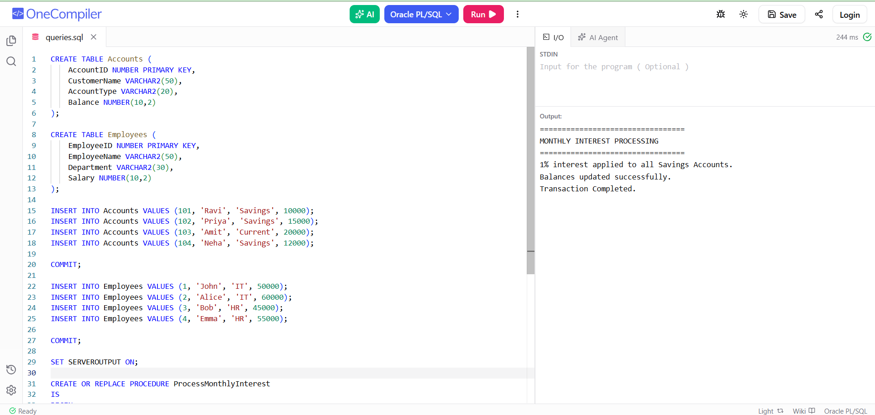

Scenario 2: The bank wants to implement a bonus scheme for employees based on their performance.
  - Question: Write a stored procedure UpdateEmployeeBonus that updates the salary of employees in a given department by adding a bonus percentage passed as a parameter.

Program Code:
CREATE OR REPLACE PROCEDURE UpdateEmployeeBonus(
p_department IN VARCHAR2,
p_bonus_percent IN NUMBER
)
IS
BEGIN
UPDATE Employees
SET Salary = Salary + (Salary * p_bonus_percent / 100)
WHERE Department = p_department;

COMMIT;

DBMS_OUTPUT.PUT_LINE('=================================');
DBMS_OUTPUT.PUT_LINE(' EMPLOYEE BONUS UPDATE ');
DBMS_OUTPUT.PUT_LINE('=================================');
DBMS_OUTPUT.PUT_LINE('Department : ' || p_department);
DBMS_OUTPUT.PUT_LINE('Bonus Added : ' || p_bonus_percent || '%');
DBMS_OUTPUT.PUT_LINE('Salary Updated Successfully.');
END;
/

EXEC UpdateEmployeeBonus('IT',10);

Output:

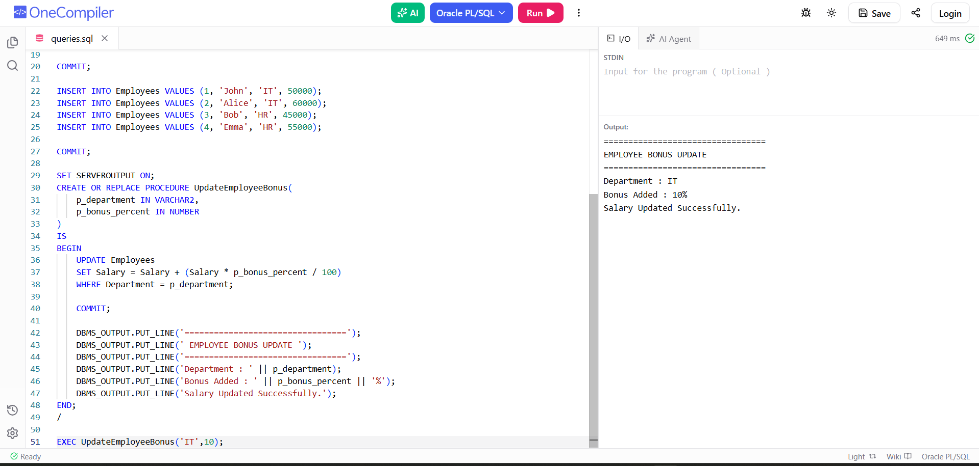

Scenario 3: Customers should be able to transfer funds between their accounts.
  - Question: Write a stored procedure TransferFunds that transfers a specified amount from one account to another, checking that the source account has sufficient balance before making the transfer.

Program Code:
CREATE OR REPLACE PROCEDURE TransferFunds(
p_from_account IN NUMBER,
p_to_account IN NUMBER,
p_amount IN NUMBER
)
IS
v_balance NUMBER;
BEGIN
SELECT Balance
INTO v_balance
FROM Accounts
WHERE AccountID = p_from_account;

IF v_balance >= p_amount THEN

UPDATE Accounts
SET Balance = Balance - p_amount
WHERE AccountID = p_from_account;

UPDATE Accounts
SET Balance = Balance + p_amount
WHERE AccountID = p_to_account;

COMMIT;

DBMS_OUTPUT.PUT_LINE('=================================');
DBMS_OUTPUT.PUT_LINE(' FUND TRANSFER SUCCESSFUL ');
DBMS_OUTPUT.PUT_LINE('=================================');
DBMS_OUTPUT.PUT_LINE('From Account : ' || p_from_account);
DBMS_OUTPUT.PUT_LINE('To Account : ' || p_to_account);
DBMS_OUTPUT.PUT_LINE('Amount : $' || p_amount);
DBMS_OUTPUT.PUT_LINE('Transfer Completed.');

ELSE
DBMS_OUTPUT.PUT_LINE('=================================');
DBMS_OUTPUT.PUT_LINE(' TRANSACTION FAILED ');
DBMS_OUTPUT.PUT_LINE('=================================');
DBMS_OUTPUT.PUT_LINE('Insufficient Balance.');
END IF;

EXCEPTION
WHEN NO_DATA_FOUND THEN
DBMS_OUTPUT.PUT_LINE('Invalid Account Number.');
END;
/

EXEC TransferFunds(101,102,2000);

Output:

